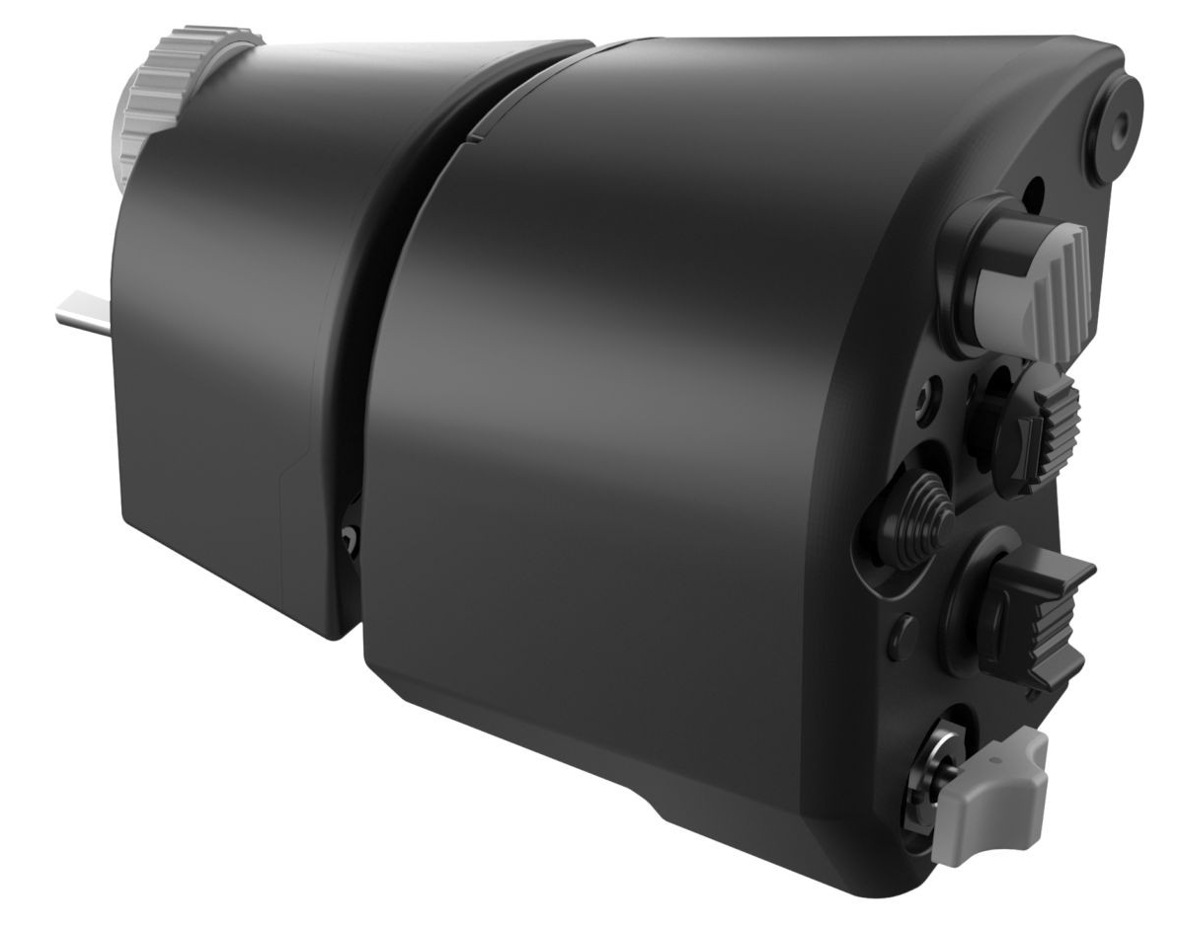  1xx - Controls | 2xx - Ground | 3xx - Flight | 4xx - A2A | 5xx - A2G | 6xx - Misc
102 - Controls - Throttle Grip
U=Up, D=Down, F=Forward, B=Backward, L=Left, R=Right, P=Press, S-*=Shift-*, L-*=Long-*

Top 3-Way Switch (spring return)
- F: --
- B: --
Mid Rear Hat (coolie)
- F: --
- B: --
- L: --
- R: --
- P: --
Mid Front Hat (dome)
- F: --
- B: --
- L: --
- R: --
- P: --
Mid Lower Hat (boat)
- F: --
- B: --
- L: --
- R: --
- P: --
Thumb Button
- P: --
Bottom 3-Way Switch (toggle)
- F: --
- C: --
- B: --
Scroll Wheel (spring return)
- U: --
- D: --
- P: --
Index Finger Hat (coolie)
- F: --
- B: --
- L: --
- R: --
- P: --
Middle Finger Hat (dish) (XY axes and buttons)
- F: --
- B: --
- L: --
- R: --
- P: --
Elevation Wheel (spring return)
- U: --
- D: --
---------------------------------------------------------------------------------------------
Right (inboard) Ring Finger Button
- P: --
Ring Finger Hat
- F: --
- B: --
- L: --
- R: --
- P: --
Left (outboard) Ring Finger Button
- P: --
Pinky Wheel (axis)
- U: --
- D: --
- Center Detent: --
Pinky Switch (spring return)
- U: --
- D: --

